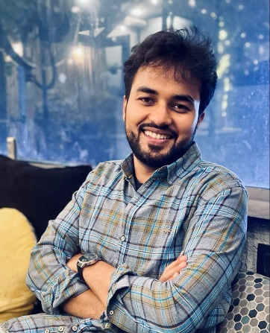
AYUSH AGARWAL
I am an Assistant Professor of Neurology at the All-India Institute of Medical Sciences, New Delhi.

Training: My medical training started in 2006 when I joined Kasturba Medical College, Mangalore for my MBBS. Thereafter, I did my MD in Internal Medicine at Sarojini Naidu Medical College, Agra and DM in Neurology at AIIMS, New Delhi.
Research areas: Deeply interested in post stroke epilepsy, primary central nervous system vasculitis and neuroprotection in stroke, apart from stroke and its care in general.
Awards: Best outgoing neurology resident in 2019, young investigator award from WSO in 2018 and 2022.
Professional: I am actively involved in clinical neurology and research for the past few years and I love to teach. My aim is to be able to increase stroke awareness to the point where people rush to the hospital immediately upon having a neurological deficit. I am also a blogger for Stroke journal for 2021-23.
Publications: Have published 50+ papers in PubMed indexed national and international journals including a randomised controlled trial on Citicoline use in hyperacute ischemic stroke and the largest cohort of PCNSV from India (third largest in the World).
In Private: I am always having a bad hair day and am an avid sports fan (watch better than I play): India, Roger Federer, Manchester United, Max Verstappen and Fernando Alonso. Animals and the people I love are my soft spot.

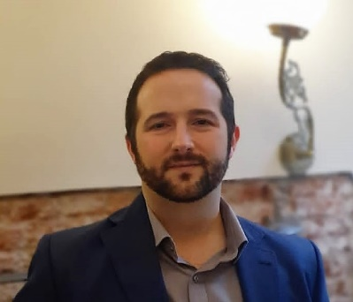
Matías J. Alet M.D.
Stroke Neurologist
Member of the Stroke Unit and staff of the Vascular Neurology clinic – Fleni, Buenos Aires
Member of the Stroke Unit – Hospital J. M. Ramos Mejía, Buenos Aires, Associate Professor – Faculty of Medicine, University of Buenos Aires

Matías Alet, born in 1985, is an Argentinian Stroke Neurologist from 2016. He is now working at two WSO/SIECV certified stroke units in Buenos Aires, Argentina.

Training: He graduated in 2011 with an honors degree from the Faculty of Medicine of the University of Buenos Aires (UBA). He completed his neurology residency at the Hospital General de Agudos J. M. Ramos Mejía, where he was later Head of Neurology Residents. Once he completed his training as a neurologist, he performed a two-year fellowship in Vascular Neurology at Fleni with Dr. Sebastián Ameriso. He is currently studying Legal Medicine.
Research areas: As a researcher, he participated in international studies such as SOCRATES, NAVIGATE-ESUS, Young-ESUS, THALES and AXIOMATIC-SSP. He also participated in national and international congresses through presentations in Vascular Neurology. He has contributed as author of scientific publications and the first inter-society local guideline on the acute management of ischemic stroke.
Currently, his greatest interest in stroke research is focused on epidemiological studies (prevalence, incidence, mortality and burden of stroke in Argentina) and on massive population surveys aimed at understanding the disease knowledge and treatment in Argentina.
Professional: He is Associate Professor in Neurology at the Faculty of Medicine of the University of Buenos Aires. He is an active member of the Stroke working group of the Argentine Neurological Society, and he has been its secretary between 2016 and 2020. Now he is member of the board of directors of the Argentine Neurological Society. He is also member of the World Stroke Organization, the European Stroke Organization and the Ibero-American Stroke Organization.
He actively participates in the Argentinian committee for the Certification of Stroke Centers in LATAM and trains multidisciplinary teams for stroke care improvement. He is a reviewer of the Argentine Journal of Neurology and Journal of Stroke and Cerebrovascular Diseases.
Publications: He has published several indexed medical manuscripts in Pubmed, and several others in national journals from Argentina. He is co-author of the first Stroke Guidelines in Argentina.
In Private: He enjoys traveling around the world and reading science fiction. He is also a self-taught cook and a weekend bike rider.

Leonardo Augusto Carbonera, M.D. M.Sc.
D.O.B. 15/April/1992, Chapecó-SC, brazil
Vascular Neurologist
Operational Leader - Clinical Trial Operations
Hospital Moinhos de Vento
Porto Alegre, Brazil

Training: He graduated in Medicine at the Universidade Comunitária da Região de Chapecó in 2014. Was trained in Neurology at the Hospital de Clínicas de Porto Alegre from 2015 to 2018 and in Vascular Neurology at the Hospital de Clínicas de Porto Alegre and the Hospital Moinhos de Vento from 2018 to 2019. Holds a Master´s Degree in Medicine - Medical Sciences, obtained at Universidade Federal do Rio Grande do Sul in 2020. He had an MBA in Business Management at Fundação Getúlio Vargas in 2021 and a Post-graduation in Clinical Research at the Brazilian Clinical Research Institute in 2022.
Research Areas: He has been involved since 2015 in stroke trials, i.e., HeadPoSt, ENCHANTED, CHARM. He was a member of the executive committee of the RESILIENT Trial, a study that led to the implementation of mechanical thrombectomy in the Brazilian public health system. Currently, he is the local PI of the Optimal Stroke Trial in Hospital Moinhos de Vento; a member of the steering committee, and leader of the executive committee/clinical trial operations of the RESILIENT DIRECT-TNK and RESILIENT EXTEND-IV trials.
Professional: He was Vice-President of Talent Management of AIESEC in Chapecó in 2011; he has been a stroke researcher since 2017; a private neurologist from 2018 until today; a telestroke neurology consultant since 2018. He worked as a researcher in the National Consortium for Quality Measures from 2019 to 2021. Currently, he works as an operational leader for the RESILIENT-TNK project, which is responsible for executing two randomized clinical trials: RESILIENT DIRECT-TNK and RESILIENT EXTEND-IV. Also works with parallel projects as a consultant for technology companies.
Publications: He has published eight indexed articles, the most relevant ones being the following: - Martins SO, … Carbonera LA, … Nogueira RG; RESILIENT Investigators. Thrombectomy for Stroke in the Public Health Care System of Brazil. N Engl J Med. 2020 Jun 11;382(24):2316-2326. - de Souza AC, Martins SO, … Carbonera LA, ... Nogueira RG. Cost-effectiveness of mechanical thrombectomy for acute ischemic stroke in Brazil: Results from the RESILIENT trial. Int J Stroke. 2021 Nov 3:17474930211055932.
In Private: He met his wife, Ana Claudia de Souza, another vascular neurologist, in 2015 during the residency, and it was love at first sight. They have a 2-year-old son named Rafael, who inherited the daddy´s hobbies of watching Formula 1 and enjoying music. Leonardo also enjoys playing keyboards and harmonica, reading and watching about generalities, and everything about airplanes.

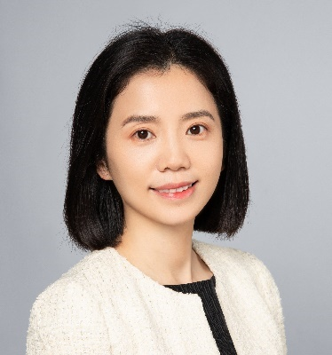
Associate Professor Xin Cheng, born in 1980, is Chief Physician and Vice Chair of the Department of Neurology,
Huashan Hospital, Fudan University,
National Center for Neurological Disorders,
Shanghai, China.

Training: She received her MD from Shanghai Medical College Fudan University (previously Shanghai Medical University) in 2003, and PhD from Fudan University in 2009. She had a research fellowship in Alzheimer’s disease at Sun Health Research Institute, AZ, USA from Nov. 2007 to Dec. 2008. She had her clinical observership at Neurology Department, Massachusetts General Hospital, MA, USA from Sep. to Dec. 2015.

Research areas: She is particularly interested in neuroimaging and treatment of acute ischemic stroke, and cerebral small vessel disease. She has established several hospital-based and community-based cohorts, and is leading several ongoing national multicenter randomized controlled trials: CHABLIS-T, CHABLIS-T II and ASPIRING-Pilot.

Awards: She has been awarded American Academy of Neurology’s 2009 and 2010 International Scholarship Award, World Stroke Organization (WSO) 2012 Young Physician’s Scholarship, WSO 2017 Young Stroke Professional Brief Clinical Exchange Scholarship and 2015 Shanghai Rising-Star Program.

Professional: She is a member of cerebrovascular group at Chinese Society of Neurology, Chinese Medical Association, Vice Chair of Society of cerebral small vessel disease, Chinese Stroke Association, and member of Standing Committee at Chinese Society of Cerebral Blood Flow and Metabolism, and member of Standing Youth Committee, Stroke Prevention Project, National Health Commission.

Publications & Grants: She authored more than 100 peer-reviewed publications, including Lancet Neurology, Annals of Neurology, Neurology etc., 3 books and 7 national guidelines or expert consensus. She has been the principal investigator of eight grants from the National Natural Science Foundation of China, Ministry of Education of China, Science and Technology Commission of Shanghai Municipality, and Shanghai Hospital Development Center.

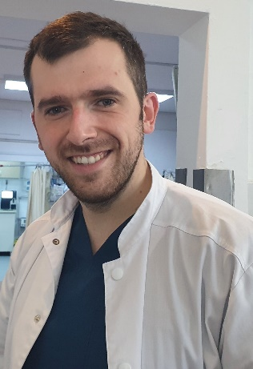
Bogdan Ciopleias is a neurologist at the Department of Neurology,
County Clinic Hospital Brasov
PhD student at Transilvania University Brasov, Romania.

He was born and raised in Brasov, Romania, were he attended and graduated from the Faculty of Medicine at Transilvania University. He completed his neurology training at the County Clinic Hospital Brasov in 2021. He attended multiple national and international seminars, courses and conferences. During his career he has been involved in numerous research projects in vascular cognitive impairment, stroke awareness, outcome in stroke patients and wearable devices in stroke patients monitoring.

In the last years he was member in the organizing committees of multiple national and international seminars and conferences in stroke, movement disorders and autonomic disfunction. He is involved in multiple activities at the European Academy of Neurology being member in different scientific panels and management groups.

He is a member of the World Stroke Organization, European Stroke Organization and European Academy of Neurology.

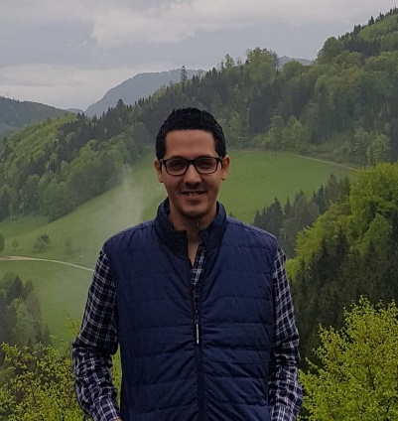

Ahmed Elkady

Ahmed Elkady is originally from Egypt. He attended Medical School in Tanta School of Medicine. He completed his Neurology residency at Mataria Teaching Hospital, Egypt and subsequently received fellowship training in Vascular Neurology at Goethe university Frankfort, Germany. Then he moved to Saudi Arabia where he currently working as neurology and stroke specialist at King Abdullah Medical City (KAMC). He received his master’s degree in neurology from Menoufia University, Egypt.
He has a strong interest in Stroke and neurocritical care. He had been Saudi German Hospital (SGH) stroke program coordinator for 2 years. He is also leader neurology investigator at SGH group. His main areas of focus are hyperacute and acute management of ischemic stroke and its impact on ischemic stroke outcomes.
He has published more than 20 peer-reviewed articles including recent original studies in the vaccine-Induced cerebral venous thrombosis (JAMA, 2021) and post COVID-19 vaccination-associated neurological complications (Neuropsychiatric Disease and Treatment, 2022). He served as educational video‐EEG cases in the database of the ILAE’s educational journal, Epileptic Disorders social media management from 2019-2022. He is a member of the European Academy of Neurology, European Stroke Organization, and the World Stroke Organization.
Apart from medicine, He has been happily married for 6 years. He is very interested in reading, watching documentaries and playing football.

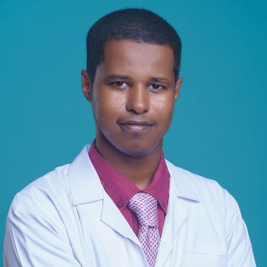
Dr. Tarig Fadalla is a medical doctor and clinical researcher at Soba University Hospital, Khartoum, Sudan.

His research work focuses on strengthening stroke healthcare services in Africa by mapping service availability and highlighting the defects. Currently, he is investigating the availability and cost-effectiveness of IV Thrombolysis and Mechanical Thrombectomy in Africa. Moreover, he is studying the contributing factors of barriers that African clinicians face to access training programs in Neurology/Neurosurgery.

Furthermore, Dr. Fadalla served as Sudan’s National Leader Investigator in the African Surgical Outcomes Study (ASOS-2), which is a landmark continental cluster-randomized controlled trial involving African researchers from 28 African countries that aimed to address the problem of post-operative death in patients in Africa. The trial successfully recruited 28892 patients from 332 hospitals in 28 African countries that participated in the trial between May 2019 and July 2020, and it shows clearly that large-scale, multi-country, randomized controlled trials led by African Researchers in Africa are feasible.

Dr. Fadalla has published several scientific papers indexed in PubMed as well as presented many scientific posters at international conferences such as “patterns, treatment, and outcomes of Subarachnoid hemorrhage in Sudan: a single center experience” at the EANS Congress 2020. In addition to “Moyamoya syndrome and stroke among pediatric sickle cell disease patients in Sudan” at MENA-SINO conference 2021. His career goal is to become a clinician-scientist, conducting translational research as well as being involved in the management of patients with brain disorders.

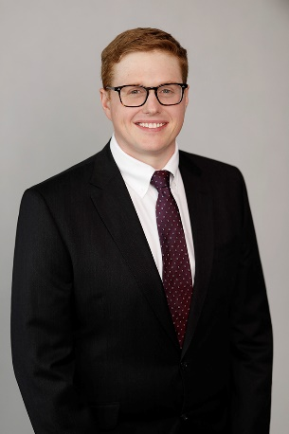

Jonathon Fanning
BSc, MBBS, PhD, FRACP, FANZCA, FCICM

Jonathon divides his time between clinical research, internal medicine, intensive care and anaesthesia. He is based in Brisbane, Queensland, Australia.

Training: Jonathon graduated in Medicine from the University of Queensland (UQ) and subsequently completed training in Anaesthesia (Australian and New Zealand College of Anaesthesia), Intensive Care (College of Intensive Care Medicine), and Internal medicine (Royal Australasian College of Physicians). During this time he also undertook a PhD (UQ, 2017) and is currently completing a Master of Science in Clinical Trials through the University of Oxford.

Research areas: Jonathon’s research program focuses on perioperative and critical care neurological injury, especially stroke. His PhD focussed on Perioperative neurological injury during cardiac surgery and intervention with particular attention to the burgeoning transcather aortic valve implantation population. The finding of >60% incidence of subclinical brain infarcts and associated early postoperative cognitive dysfunction has led to further investigation in to neuromonitoring strategies and anticoagulation strategies to minimise this injury.

Awards: The above work has resulted in over $1.5 million in competitive research funding and opportunities throughout Australia and internationally, including, most recently, a Fulbright Scholarship to Johns Hopkins Medicine, Baltimore, USA.

Professional: Jonathon has several leadership roles across both academic and clinical medicine. This includes as a Senior Lecturer with the University of Queensland and Staff Specialist in the Internal Medicine & Aged Care Services of the Royal Brisbane & Women’s Hospital, Queensland, Australia. He is the lead of clinical research conducted by the Critical Care Research Group.

Publications: Over 60 publications in international peer-reviewed journals. 4 text book chapters. 3 National Therapeutic Guidelines. Review Editor with Frontiers Neurology and active reviewer for numerous top-tier journals including Journal of Neurology and Neurosurgery, Circulation, JAHA, and Neurology.
In private: He is happily married for 10 years with his wife Erin and is father of three children. Hobbies include woodwork, both classical and rock music, good food and red wine.

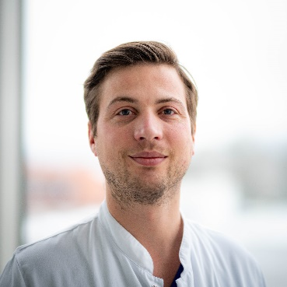
Stefan Gerner

Stefan Gerner is a neurologist and assistant professor at the Dpt. of Neurology of the University hospital Gießen, in Hesse, Germany. His clinical expertise focuses on stroke and acute neurological diseases.

Dr. Gerner was born and raised in Nuremberg, before moving to Erlangen where he attended university. There, he was graduated with a Medical Degree in 2014 and started his residency training as a neurologist at the University hospital of Erlangen (chair: Prof. Dr. Dr. Stefan Schwab). In 2021 he moved to Gießen, where he completed his residency training and became assistant professor and co-director of the stroke unit at the local university hospital. Further, he is responsible for the local neurovascular sonography unit.

In 2014 Dr. Gerner finished his medical doctor degree at the University hospital of Erlangen. His early research work focused on prognostication and treatment in patients with hemorrhagic stroke. For his post-doctoral thesis, which he completed in 2020, he worked on intercebrebral and subarachnoid hemorrhage, the outcome of these patients, therapy and quality of life after onset of these serious diseases. He has published several articles in peer-reviewed journals and text books. Currently, he is involved in the development of a local stroke registry with focus on multi-omics in lacunar stroke and intercellular communication in the CNS.

Since 2021 Dr. Gerner leads his own research group, which consists of five residents and PhD students.

Dr Abdul Hanif Khan Yusof Khan
MB, BcH, BAO (Ireland), BMedSc (Ireland),
Master of Medicine (Internal Medicine), MMed (UPM)

Dr Abdul Hanif Khan Yusof Khan, born in 1985, is currently a Neurology Fellow and Medical Lecturer under the supervision of Professor Dr Hamidon Basri in Hospital Pengajar Universiti Putra Malaysia (HPUPM), Serdang, Malaysia.
Training: He graduated in 2010 from the Royal College of Surgeons In Ireland with a double degree in Medical Sciences (BMedSc) and a Bachelor's Degree in Medicine and Surgery (MB, BcH, BAO). Subsequently, he completed his Master's Medicine (Internal Medicine) at Universiti Putra Malaysia (UPM) in 2018 and currently doing his fellowship in Neurology with a special interest in stroke.
Research areas: He has a special interest in stroke and HPUPM principal investigator for the OPTIMIST Trial (trial on low-intensity monitoring post thrombolysis) and co-investigator of the AVERT DOSE Trial. He is also involved with the international Neuro-COVID coalition that is actively involved in research and publications, especially on neurological complications post-COVID. He is also involved in rare genetic disease research and is currently doing family genetic analysis in Myotonia Congenita. Awards: He was awarded the "Rising Star Award" from the Malaysia Stroke Council due to his active involvement in stroke education, especially in developing the Malaysia stroke certification e module and raising public awareness on stroke in conjunction with World Stroke Month since 2019.
Professional: Dr Abdul Hanif Khan, is currently the Secretariate Member of the Asian Oceanian Association of Neurology (AOAN). He is also a member of the World Stroke Organisation and the International Parkinson and Movement Disorder Society. Nationally, he is co-ordinator of the stroke certification module and a member of the stroke preceptorship programme under the Malaysia Stroke Council.
Publication: Dr Abdul Hanif Khan, is actively involved in publishing since 2019, where he has authored and co-authored nearly 40 articles with an H Index of 4. He was recently published in Annals of Neurology for his work with the International Neuro-COVID coalition. He is also the co-author of the 3rd Malaysia Clinical Practice Guideline (CPG) on the management of ischemic stroke and Malaysia Consensus on the management of Patent Foramen Ovale (PFO). Private: He is happily married with two daughters, with the third on the way. He enjoys travelling and spending most of his time with his family and friends.

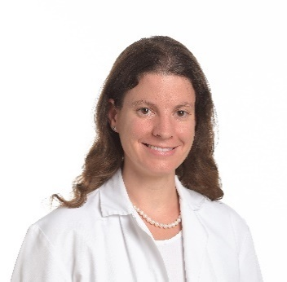

Mirjam R Heldner

Mirjam R Heldner, born in 1984, is a Swiss Neurologist and Strokologist at the Stroke Center Bern since 2010. She is Associate Professor for Neurology and Stroke, at the Faculty of Medicine, at the University of Bern (Switzerland) and Deputy Head of the Neurovascular Outpatients Clinics, at the Department of Neurology, at the University Hospital of Bern (Switzerland).
Training: She graduated in 2008 from the Faculty of Medicine, at the University of Bern (Switzerland). She studied and trained as a Neurologist and Strokologist in Bern (Switzerland). She spent a 1.5-year fellowship at the Nuffield Department of Clinical Neurosciences, at the University of Oxford (United Kingdom) with the Oxford Vascular Study Group in 2016/2017. She completed a European MSc Stroke Medicine (ESO), at the Danube University of Krems (Austria) in 2018.
Research areas: As a researcher, she participated in several international studies such as ARUBA, SOCRATES, CADISP-Plus, TREAT-CAD and CONVINCE. She is reviewer of several international high-ranking journals. She has actively participated in several national as well as international conferences. Her research interest focuses on large vessel occlusions, stroke scales, emergency triage, acute therapy, atherosclerosis in different vascular beds, intracranial stenosis, secondary prevention and cerebral venous sinus thrombosis.
Awards: She has received several awards as first, last or co-author (e.g. by WSO, ESO, Paul Dudley White International Scholar Award, EJoN Award, Peter Huber Award, Day of Bernese Clinical Research Award, SFCNS Award).
Professional: She is Associate Professor for Neurology and Stroke at the Faculty of Medicine, at the University of Bern, in Switzerland. She is as member of different professional associations. She is a member of the evaluation committee of grants for trainees and equality for protected research time and member of the executive committee of clinical neuroscience at the University of Bern. She is mentoring CWIN (Connecting Women In Neurosciences) at the University of Bern. She is co-organiser of the ESO-ESO-department-to-department visits at the Stroke Center Bern. She is part of the faculty of the ESO-ESMINT-ESNR Stroke Winter School and of the MAS Stroke Medicine, at the University of Bern.
Publications: To date, she has published around 150 publications, of which the majority are original contributions in international high-ranking journals. Special interests: Her current priorities are the implementation of the ESO European Stroke Action Plan, the promotion of junior strokologists – especially those from middle- and low-income countries, from Eastern Europe and gender equality and equity. In private: She enjoys travelling, skiing, hiking, reading, photographing, and visiting museums and experiencing cultural events.
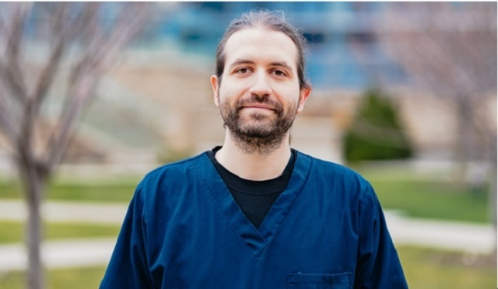

Aristeidis Katsanos, MD, PhD, FCSC-S born in 1988, is a Vascular Neurologist, Assistant Professor at the McMaster University and Investigator at the Population Health Research Institute (PHRI), Hamilton, ON, Canada.

Training: Aristeidis obtained his Medical Degree from the University of Ioannina, School of Medicine, Ioannina, Greece and completed his training in Neurology at the University of Ioannina and at the National and Kapodistrian University of Athens, Greece. He completed his PhD thesis at the Department of Neurology, University of Ioannina, investigating the contribution of transesophageal echocardiography in the diagnostic work-up of patients with stroke. After the completion of his PhD thesis and training in Neurology he was granted a 6-month European Academy of Neurology (EAN) Research Fellowship at the Ruhr University of Bochum, Germany and afterwards he commenced a 2-year stroke fellowship at the Division of Neurology at McMaster University.
Research areas: His research focuses on emerging neurosonology applications and the evidence-based evaluation of novel therapies in acute stroke treatment and secondary stroke prevention. He serves as the Co-PI of two phase 2 randomized controlled clinical trials evaluating optimal blood pressure control after endovascular thrombectomy (DETECT; NCT04484350) and the use of colchicine for the prevention of vascular events after an acute intracerebral hemorrhage (CoVasc-ICH; NCT05159219).
Awards: He has been the recipient of the EJ Moran Campbell Award from the Department of Medicine, McMaster University, the Young Investigator Award from the European Stroke Organisation (ESO), the Outstanding Reviewer Award from Stroke and an award from Web of Science-Clarivate analytics for placing in the top 1% of reviewers in 2018 in Neuroscience and Behavior on the Publons Global Reviewer Database.
Professional: He serves as an Associate Editor for Frontiers in Neurology (“Section Stroke”), Academic Editor for PLoS One, member of the Editorial Boards of Stroke, European Stroke Journal and the Journal of Neuroimaging. He serves as a member of the Guidelines Committee and the Young Stroke Physicians & Researchers Committee of the ESO, member of the Digital Content Committee of the Canadian Stroke Consortium and member of the Communications Advisory Group of the PHRI.
Publications: He has published more than 200 papers and more than 60 abstracts in high-impact medical journals to date (>5000 citations, H-index 43).
In Private: He loves music, travelling and poetry. He has been a guitarist in several bands and has released two full length albums of sonic landscaping and ambient music (https://www.discogs.com/artist/1926335-Aristidis-K)

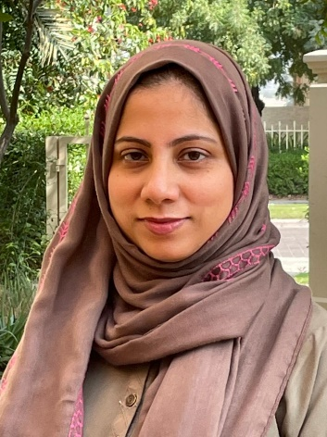
Dr. Maria Khan Junaidi

I am a Specialist Neurologist at Rashid Hospital in Dubai, UAE. I graduated from the Aga Khan University Medical College in 2001. After completing my training in neurology, I went on to do fellowships in Vascular neurology and Cerebrovascular translational Research. I also hold a Masters in Epidemiology and Biostatistics from the Aga Khan University where I graduated with high honors.

For the past eight years I have been living in Dubai, UAE. Here, I have had the opportunity to work closely with other stroke neurologists in the region. I am also one of the board members for the Middle East North Africa Stroke Organization. Under this umbrella, along with other colleagues from the region, I have been involved in various educational activities to improve stroke care. In this respect, I have conducted training sessions for neurologists and nurses from other Emirates in the UAE as well as from other countries including Bahrain and Kenya.

I have been the stroke lead from my hospital for a recent accreditation as a Comprehensive Stroke Center from the American Heart Association. We are one of the first two centers outside of the USA, to receive this certificate. As a member of MENASO, I am now actively involved in guiding other centers to streamline their processes for a similar accreditation.
My other main interest is in research. I have so far authored over 40 articles in peer reviewed journals, and I frequently present at international and regional conferences.

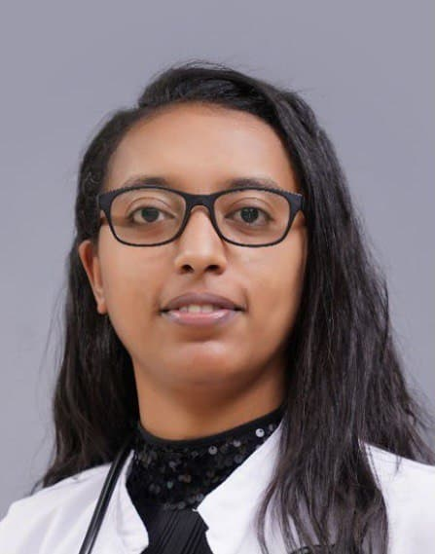
Dr.Selam Kifelew Melkamu is an Assistant Professor of Neurology in Department of Neurology, Addis Ababa University, College of Health Sciences, Ethiopia.

Dr. Selam currently works as a neurologist in one of the largest referral hospital in Ethiopia, Tikur Anbessa Specialized Hospital. She is a postgraduate coordinator for Attaching Residents. She is also involved in teaching and mentoring postgraduate and undergraduate studentsattaching neurology. Dr. Selam is a member of the Association of Ethiopian Neurologists.

She provides professional support to two patient organizations in the country, namely Parkinson Patients Support Organization and Care Epilepsy. She is a mother of two.

Ralph Kwame Akyea PhD, MPH, MB ChB, BSc
Senior Research Fellow
Centre for Academic Primary Care
Lifespan and Population Health Unit
School of Medicine
University of Nottingham
United Kingdom

Dr Ralph Kwame Akyea, born in Accra, Ghana (in West Africa), is a Medical Epidemiologist with
the Primary Care Stratified Medicine Research Group, Centre for Academic Primary Care,
University of Nottingham, UK.
Training: Ralph received his medical degree from the University of Ghana Medical School in 2012. He earned both his master’s degree in Public Health (MPH) in 2016 and a doctoral degree in Primary Care in 2022 from the University of Nottingham.

Research areas: Ralph’s research involves the use of large health databases (routinely collected
electronic health records and cohort data). He applies novel epidemiological, statistical, and data science methods to understand disease heterogeneity and identify unique patient groups at high risk of adverse cardiovascular morbidity and mortality outcomes. He collaborates extensively with multidisciplinary research teams, charities, and Patient Public Involvement & Engagement Groups to improve clinical outcomes.

Awards: Ralph has received many awards including the British Computer Society Primary Health
Care Specialist Group Early Career Researcher Award and the Gertrude Cropper Endowed Award
from the University of Nottingham.

Professional: Medically qualified with years of experience in clinical practice in resource-limited
settings.

Publications: Over 33 peer-reviewed publications, including in Lancet Public Health, BMJ Heart,
Stroke, and European Journal of Preventive Cardiology. He was awarded BMJ Heart Best Research Paper of the Year for 2019.

In private: Ralph enjoys traveling, cycling, walking, listening to ‘good’ music and audiobooks,
and watching documentaries/docuseries. He believes in lending a hand to aspiring academics and professionals and commits his time to teach, assist and encourage them at various stages of their journey. He is a son, brother, husband, and father.

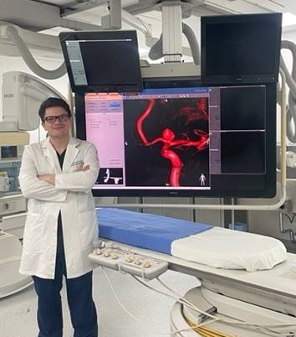
Javier Lagos-Servellón, MD
Clinical Neurologist from Honduras
Senior Fellow Interventional Neurology-Mexico

Javier Lagos-Servellón: Born in 1989, in Tegucigalpa the capital city of Honduras, Tegucigalpa.

Training: Graduated in Neurology in National Autonomous University of Honduras. I also made Clinical Neurology residency in Hospital Escuela from the National Autonomous University of Honduras and graduated with honours-Magna Cum Laude. Currently in my second and final year of Interventional Neurology in Centro Medico Nacional “20 de noviembre” from the National Autonomous University of Mexico. In the time period from March- June 2022 I spent an Observerhsip in the Department of Diagnostic and Interventional Neuroradiology in Bern, Switzerland

Research Areas: The research area I have been developing is the application of technologies in the education and awareness of Stroke through smartphone apps. I also had a role in the development of the first stroke registry in the largest referral hospital in Honduras, data that was published at the 2020 WSO congress.I am working on the potential applications for Artificial Intelligence in stroke networks and detecting complications due to dysphagia. Upon returning to Honduras, I will support the Latin American registry of Stroke LASE.

Awards: I was selected as the “best resident “of Neurology in 2020. I currently serve as chief resident of Interventional Neurology in Centro Medico Nacional “20 de noviembre” in Mexico.In 2021, I received the award for the best research work by the Faculty of Medical Sciences of Honduras and multiple grants for assistance of INR conferences, also recognized and granted by the WFITN for an observership in the Department of Diagnostic and Interventional Neuroradiology in Bern, Switzerland.

Professional: Chief of residents of Interventional Neurology. Active member of ALATAC “Alianza Joven Latinoamericana contra el ACV” translated as” Young Latin American Alliance Against Stroke” and part of the Research Committee of this organization. Member of Society of Vascular and Interventional Neurology(SVIN), European Society of Minimally Invasive Neurologica Therapy and the World Federation of Interventional and Therapeutic Neuorradiology (WFITN)

Publications: I have published in local journals in Honduras on the current status of cerebrovascular disease from a national and public health perspective. These publications emphasize the opening and extension of acute recanalization therapy.In the same way, I have published the efforts of stroke awareness campaigns in abstracts published in the International Journal of Stroke. I have published clinical cases and aneurysm care systems as abstracts in SVIN's Stroke journal.

In Private: I currently live temporarily in Mexico City, with plans to return to northern Honduras. I love spending time with my family whenever I can. I like travelling, learning about different cultures, biking, cooking, and eating good food. I read science fiction, meditation, science, nonfiction and self-improvement books. My biggest passion is music, with a healthy obsession of collecting vinyl records of different types of music.

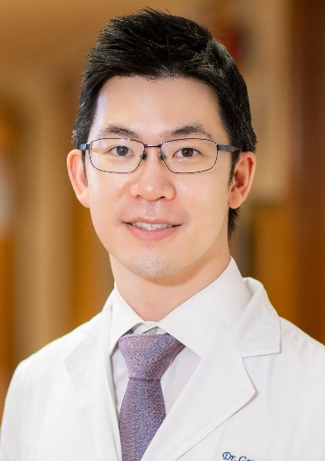
Gary Kui Kai Lau
Clinical Associate Professor in Neurology, The University of Hong Kong

Gary Kui Kai Lau graduated in 2008 from the University of Hong Kong with a MBBS and Master of Research in Cardiovascular Medicine degree. He joined the Division of Neurology, University of Hong Kong as Clinical Assistant Professor in 2011 under the prestigious Young Academic Scheme. He completed his Neurology training at Queen Mary Hospital in 2015 and subsequently received a PhD in Clinical Neurosciences (Stroke medicine) in 2018 (University of Oxford Croucher Scholar) at The Centre for Prevention of Stroke and Dementia, University of Oxford, under the mentorship of Professor Peter Rothwell. He was promoted to Clinical Associate Professor in 2022.
Dr Lau’s research focuses on the causes of stroke and improving the prevention of stroke. He has published over 130 research articles or book chapters relating to stroke, including in reputable journals such as Lancet Neurology, Lancet Infectious Diseases, European Heart Journal, Nature Communications, JAMA Neurology, Neurology and Stroke. He currently leads the Stroke Research and Prevention Group at HKU, and is the Principal Investigator / Co-Principal Investigator of four prospective stroke registries in different regions of Hong Kong. He pioneered the WeRISE App – a one-stop platform for stroke patients and families combating stroke. This App has been widely utilised and disseminated throughout the medical and social sectors of Hong Kong.

Dr Lau is a recognised regional leader in stroke and is a Founding Steering Committee Member of the Microbleeds International Collaborative Network (MICON), Steering Committee Member and Country Lead of the International Multicentre Patent Foramen Ovale and Stroke registry (IMPROVE) and Founding Committee Member of the Neurological and Mental Health Global Epidemiology Network (NeuroGEN). He is a Director of the Hong Kong Stroke Fund, Honorary Treasurer of the Hong Kong Stroke Society, and currently serves as an Honorary Advisor for the Hong Kong Stroke Association and Hong Kong Society for Rehabilitation.
Dr Lau has also made substantial contributions to teaching and learning, in particular relating to innovative pedagogies in eLearning. He is currently the Director of Educational Technology at HKUMed, is the Founding Editor of the HKU eLearning Platform in Clinical Neurosciences and was the Chief Coordinator of the HKU eLearning Platform in Clinical Medicine.
In recognition of his clinical, research and teaching excellence, Dr Lau has been awarded the Paul Dudley White International Scholar Award, American Heart Association Award for Patient-Oriented or Clinical Research in Hypertension, Hong Kong West Cluster Outstanding Team Award for Comprehensive Acute Stroke Service; Faculty Teaching Medal, British Medical Association Award for a highly commended title under ‘Neurology’ and Smart Ageing Gold Award from the Golden Age Foundation.

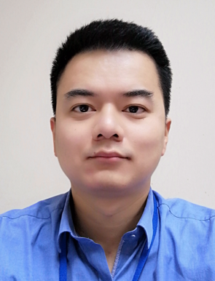

Associate Professor Dr Zhe Kang Law
MD(Hons), MRCP(UK), CCST, PhD, FRCP
Consultant physician and neurologist
Neurology Unit, Department of Medicine
UKM Medical Centre
Kuala Lumpur, Malaysia
National University of Malaysia,
Kuala Lumpur, Malaysia

Dr Zhe Kang Law, born 1982, is a consultant physician/neurologist and associate professor at the National University of Malaysia, Kuala Lumpur, Malaysia.

Training: He graduated from medical school, National University of Malaysia in 2007, passed Membership of College of Physicians, MRCP(UK) exam in 2011 and completed a Malaysian neurology subspecialty training programme in 2016. In 2019, he completed a PhD in Stroke Medicine at the University of Nottingham, United Kingdom under the supervision of Professors Nikola Sprigg and Philip Bath. Between 2019 to 2021, he undertook a post-doctoral fellowship at the Lewy Body Lab, Newcastle University, UK, before returning to Malaysia in June 2021.

Research areas: His main research focus is on intracerebral haemorrhage. For his PhD thesis, he worked on data from the Tranexamic acid in IntraCerebral Haemorrhage-2 (TICH-2) randomised controlled trial. He was the Malaysian national coordinator of TICH-2 and currently ongoing Tranexamic acid for hyperacute spontaneous IntraCerebral Haemorrhage-3 (TICH-3) randomised controlled trial. He was also involved as an investigator/ trial physician for several stroke randomised controlled clinical trials, including RIGHT-2, RESTART, SOSTART, RESTORE brain, LACI-1, ATTEST-2, TASTE, TWIST, WAKE-UP and TRIDENT.

Awards: He was awarded the Young Investigator Award 2021 by the Malaysian Stroke Council. He also won the Hoff’s Award for best oral abstract in 2017 World Intracranial Haemorrhage Conference, and institutional excellent clinical service award in 2016, and excellent publication award in 2018 and 2020. He also won the Malaysian Society of Neurosciences best publication award for 2020 and 2022.

Professional: He is a member of World Stroke Organisation, European Stroke Organisation, Malaysian Stroke Council, Malaysian Society of Neurosciences and Malaysian Academy of Medicine. He is a Fellow of Royal College of Physicians (Edinburgh). He is a member of editorial board for European Stroke Journal and an associate editor for Neurology Asia. He is a reviewer for several stroke/neurology journals including European Stroke Journal, Stroke and Vascular Neurology, Translational Stroke Research, International Journal of Stroke, Cerebrovascular Diseases, Neurology Asia, Frontiers in Neurology, BMJ Open and Thrombosis Research. He has given platform presentations in local and international conferences including in European Stroke Organisation Conference, World Stroke Congress, UK Stroke Forum and Malaysian Stroke Conference.

Publications: He has authored 64 journal articles to date including in the Lancet, European Stroke Journal, Stroke, International Journal of Stroke, Translational Stroke Research, Cochrane Systematic Reviews, JNNP and JAMA Neurology. His h-index is 16 (google-scholar citations). He is also a member of the evidence reviewer team for the 6th National Clinical Guideline for Stroke for the UK and Ireland, which is currently being drafted. He is coordinating the first Malaysian guideline on management of intracerebral haemorrhage.

In Private: He is happily married to Swee Wei, a lung transplant physician, to whom he provides statistical service on occasions. They have a 9-year-old daughter and a 6-year-old son. He is a chess fanatic and dreamt of becoming a chess grandmaster before he took up a medical career.

Linxin Li

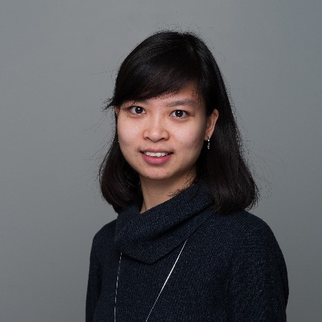
I’m a senior research fellow at the Wolfson Centre for Prevention of Stroke and Dementia, Nuffield Department of Clinical Neurosciences, University of Oxford.

I was trained as a neurologist in China before moving to the UK to complete a DPhil with Professor Peter Rothwell at Oxford University. I have since continued to work with Peter and the ongoing population-based Oxford Vascular Study. Currently, I lead a multicentre cohort study looking at the causes and prevention of stroke at younger ages (Thames Valley Young Stroke Study).

My main research interest is clinical stroke epidemiology, with a strong focus on stroke prevention and more recently particularly on stroke prevention at younger ages. Findings from our work have resulted in >90 publications in well-respected journals in the field, including several first-author papers published in the Lancet, JAMA, BMJ, Lancet Neurology and JAMA Neurology. I was awarded the Young Investigator Award from the European Stroke Organisation (ESO) for contribution in improving the understanding of the role of traditional and rare risk factors in cryptogenic stroke and have been an ESO Fellow since 2017. In addition, I also received the Emerging Aspirin Investigator Award from the International Aspirin Foundation for work on long-term benefit and harm of aspirin at older ages in secondary prevention of stroke.

I have always been very compassionate about teamwork and I’m also keen to facilitate collaboration between colleagues and to nurture younger generations of clinical researchers. I currently serve on several professional committees, including the British & Irish Association of Stroke Physicians and ESO, and sit on several editorial boards, including the European Stroke Journal and the ESO education platform.

Outside work, I enjoy classic music and hiking.

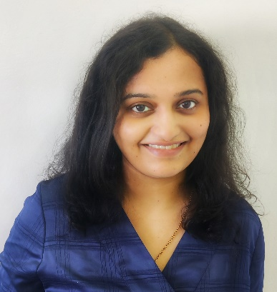
Radhika Lotlikar

I was born in Ratnagiri, a small port city in Maharashtra in 1989. Inspired from my physician father and mindful of the urban–rural gap at the grassroot led me to pursue healthcare as my career path.
I completed my Bachelor of Medicine and Bachelor of Surgery from the prestigious Seth G S Medical College and KEM Hospital Mumbai, Maharashtra from 2007-2013. This period widened my perspectives to have a cross cultural experience, peer to peer interactions along with exposure to varied patient population and postings in rural parts around Mumbai.
I pursued my postgraduation degree as an internal medicine resident in Government Medical College Aurangabad, Marathwada division of Maharashtra from 2014-2017. The entire experience of dealing with poor patients, creating awareness among the commons and unmet needs of the population, participating in social activities rooted my interest in human nature and neurosciences. I received the best paper award for my thesis on “Diastolic dysfunction in normotensive type 2 diabetes mellitus” in RSSDI national conference 2017.
I worked as a Senior Registrar in Dr R N Cooper Hospital, Juhu, Mumbai from 2017-2018 where I had an opportunity to teach the medical and nursing students. I also participated in patient awareness programs with the local communities.
My neurosciences journey began with selection for super specialty neurology residency in Sree Chitra Tirunal Institute for Medical Sciences and Technology, an Institute of National Importance located in Thiruvananthapuram, Kerala. I completed my training from 2019- 2021 and was privileged to work in the comprehensive stroke care center under the able guidance and mentorship of Dr P N Sylaja. The significant impact of an integrated stroke management team on the patient outcome inspired me to undertake stroke related activities along with research projects.
My neurology residency training gave me the opportunity to be a part of various projects related to neuro-immunology, epilepsy and particularly stroke; the work I could present in three national conferences along with a best paper award in study on Semiology of TLE and Post-operative Outcome in Agrim National Neurology Conference in October 2020. Last year, I presented my work in three international conferences, namely, 13th Asian & Oceanian Epilepsy Congress June 2021, 25th World congress of Neurology, Rome, and 11th World Stroke Congress in October 2021.I received the young investigator award for my study "Predictors of recurrence in large artery atherosclerosis and cryptogenic strokes- a comparative study" in 11th world stroke congress,2021. During my neurology residency, I was a part of 6 publications including my stroke project, immunological study on NMO spectrum disorders, case reports and case series involving COVID related neurological diseases.
On February 2022, I began my post-doctoral fellowship in stroke intervention and cerebrovascular disorders under the mentorship of Dr Boby Varkey in Aster Medcity, Kochi, Kerala. My areas of interest include stroke prevention, acute stroke care, interventional management and rehabilitation strategies and have 3 projects in pipeline.

Living in different regions of the country has made me experience immense cultural diversity, exposure to multiple languages and widen my communication skills. I am recently married to a rheumatologist, and I love to travel, dance, enjoy deep conversations, read science fiction, create happy memories and build social connections.

I envision to use my experience in creating awareness and building a strong stroke network collaboration in India and globally.

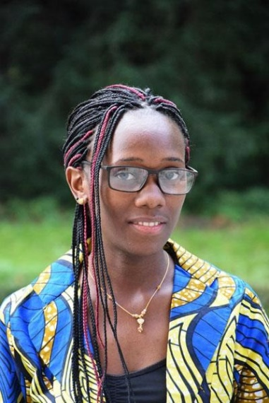
Sarah Matuja

(MD, MMed, MSc Neurology Fellow) is a Senior Lecturer in the department of Internal Medicine, Neurology division at the Catholic University of Health and Allied Sciences-Weill Bugando (CUHAS-Bugando) in Northwestern Tanzania, where she has been re-categorized since July 2022. She completed her medical school training at CUHAS-Bugando in 2013 and completed her Master of Medicine Training in December 2019. She is currently a Neurology Fellow at the Muhimbili University of Health and Allied Sciences in Tanzania

Dr. Matuja is a vibrant stroke researcher and has published multiple research articles focusing on the morbidity and mortality of stroke among Tanzanians. Her previous research work is based on stroke in young adults which has been on the rise among Tanzanians due to the upsurge in the prevalence of cardiovascular diseases and is associated with devastating outcomes. She is currently managing the Weill-Bugando Department of Medicine’s stroke registry since 2020, and the goal of this registry is to improve quality of care for patients and to identify research gaps. Similarly, she is also collaborating to write a book about stroke in Low- and Middle-Income Countries with neurologists across the globe.

Dr. Matuja also serves as an active member for the Non-Communicable Diseases Group in Tanzania, a position which she leverages to promote locally contextualized research and preventive strategies from stroke. She is a current scholar for the Training Africans to Lead and Execute Neurological Trials program and a former Global Health Fogarty Fellow, supported by National Institute of Neurological Disorders and Stroke, National Institutes of Health. Her ultimate career goal is to conduct collaborative clinical research in Tanzania, sub-Saharan Africa and globally that is focused on stroke and will improve the health and outcomes of people with stroke, especially in Tanzania.

Jatinder Minhas BSc MBBS MRes MD FHEA
Clinical Associate Professor /
Honorary Consultant Stroke Physician
Department of Cardiovascular Sciences
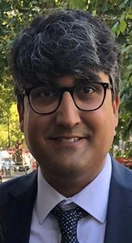
NIHR Leicester Biomedical Research Centre
University of Leicester
United Kingdom

Dr Minhas is Clinical Associate Professor of Stroke Medicine at the University of Leicester. He has a strong research interest in cerebral haemodynamic changes during acute stroke and currently supervises a number of doctoral students studying this field.
Training: He graduated in medicine from Norwich Medical School and completed clinical academic training on the National Institute for Health and Care Research (NIHR) Walport Pathway. He gained an externally funded doctoral Fellowship prior to completing an NIHR Clinical Lectureship in Older People and Complex Health Needs.
Research Areas: His research endeavours to bridge the gap between technical studies in cerebrovascular physiology (particularly acute intracerebral haemorrhage), and delivery of clinical stroke care and research. He strongly believes this niche is vital for delivering technically excellent and innovative translational programmes of research with the potential to deliver significant improvements in stroke care, in reasonable time frames.
Awards: He received the College of Life Sciences Lauder Prize (best research MD), a European Stroke Organisation award (novel study design), and a Royal College of Physicians Quincentennial Lecturer award (excellence in research).
Professional: He currently sits on the European Stroke Organisation Simulation Committee, East Midlands NIHR Regional Advisory Committee for Research for Patient Benefit and is East Midlands Clinical Research Network Ageing Lead. Previously, he was one of the inaugural cohort of British and Irish Association of Stroke Physicians ‘TakeUp’ Stroke Fellows.
Publications: He has 92 peer-reviewed publications (2464 citations, h-index 17, i10-index 32) to date, 32 as first author and 14 as senior author. His work recently directly informed Guideline 7.3 in the 2022 American Heart Association/American Stroke Association Intracerebral Haemorrhage Guideline.
Personal Life: He is happily married to his wife Dimple, a Paediatrician with a special interest in Diabetes. He has two sons aged 7 and 3. In his spare time, he enjoys playing and coaching football (has the Football Association Level 1 Qualification), watching cricket and learning to grow olive trees. In 2021, he completed the London Marathon with his father, raising money for his local stroke recovery support group.
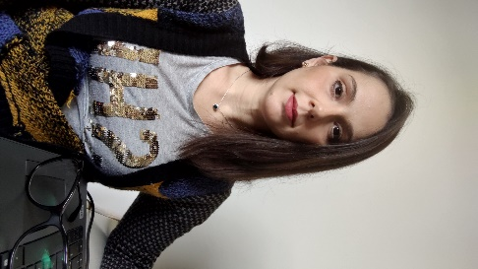

Maria Giulia Mosconi
Medical Doctor Clinical Researcher
Cardiovascular-Stroke Unit Department
University Hospital of Perugia
Italy

I was born in 1985 in a town in the centre of Italy. My life partner, Giorgio, and I happily live in Perugia with our two sons. I like yoga and trekking; I did a part of Santiago’s walk alone and hoped to finish it one day, maybe with my family. I love travelling, good food and wine, but why not also beer? I like rock and classical music and love ballet.

Training. I got my general degree in Medicine in 2012 after a 2-year internship in the Cardiovascular-Stroke Unit Department at the Hospital in Perugia. I presented my thesis on “Inferior vena cava filter in preventing pulmonary embolism in patients with acute stroke: indications and outcome.”. Between 2013 and 2018, I pursued my specialisation in Emergency Medicine. The 5-year course occurred mainly in the Cardiovascular-Stroke Unit Department of the Hospital in Perugia. In 2018 I presented the thesis for my specialization entitled “SMASH-U Classification in Acute Haemorrhagic Stroke Patients: A Rapid Tool for Etiological Diagnosis and Management” (DOI: 10.1007/s11739-020-02330-2).

Research areas. The main areas of my research work are centred on acute ischemic stroke treatment and secondary prophylaxis. I took part in several randomised controlled trials as a sub-investigator (RESPECT-ESUS, PACIFIC AF, PREVENTIHS), sub-investigator and Italian Trial Coordinator (PACIFIC STROKE, PRESTIGE AF), principal investigator of an RCTs (AXIOMATIC SSP); I also collaborated in several prospective international studies (RAF, RAF-NOAC, RENO, RENO extend). I have several publications on these topics.

Professional. In 2018 I was co-author and Editorial Coordinator of the Italian National Observatory on Stroke Report, which was presented in the Italian Parliament. The same year, I attended the SAFE Working Conference and General Assembly as the Italian delegate in November. During the post-specialization period, I was active in promoting stroke awareness. From December 2018 to March 2020, I worked in the Cardiovascular-Stroke Unit Department at the Hospital in Perugia, collaborating in activities as an expert in Emergency Medicine for the project proposed by the Internal, Vascular and Emergency Medicine-Stroke Unit: "Implementation of the number of patients with acute ischemic ictus treated with systemic thrombolysis and mechanical thrombectomy at the Stroke Unit of the Perugia Hospital". I then worked as an Internal-Emergency Medicine physician from March 2020 to September 2021 at the Hospital in Perugia in the Cardiovascular and Emergency Medicine-Stroke Unit for COVID-19 emergencies and stroke services, from the acute phase to discharge management. I accepted the role of Clinical researcher for Perugia University in September 2021 while maintaining total clinical activity in the Cardiovascular and Emergency Medicine-Stroke Unit. I am active in several medical and scientific societies (ESO, SIMEU, SIMI, SISET, ISA-AII) and their young sections.

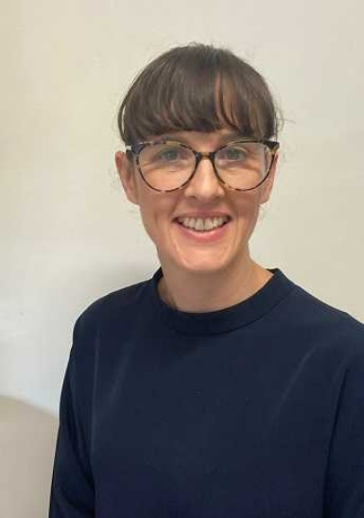
Emily Ramage is a physiotherapist and researcher with over 15 years clinical experience and is the Allied Health Research and Knowledge Translation Lead at Western Health, Victoria Australia.

Training: Emily graduated with a Bachelor of Physiotherapy (Honours) from Melbourne University in 2004. Emily began her PhD in mid-2018 submitted her PhD (Doctor of Philosophy, Physiotherapy) in Sept-2022.
Research: Emily’s doctoral work involved the co-design of a telehealth-delivered physical activity intervention aimed at reducing stroke recurrence risk and piloted it as part of the ENAbLE pilot trial. Emily and her team have published a guide to co-designing research for testing in clinical trials. Emily’s has a strong interest in stroke prevention particularly in high-risk cohorts (both primary and secondary prevention) and technology to improve care after stroke. Emily recognises the benefits of involving those who the research is designed for in the research and enjoys working collaboratively in her work.
Professional: Emily is a member for the Executive Committee of the Stroke Society of Australasia Emerging Stroke Clinician and Scientist Special Interest Group and the PhD candidate representative on the ACTIOnS (ACtivity To Improve Outcome after Stroke) research collaboration. Emily is also an Early-Career Researcher Editorial Board Member of the Health Expectations journal
Outside of research: Emily lives in Melbourne Australia with her husband and three children. Emily enjoys hiking, travel and spending time with family and friends.

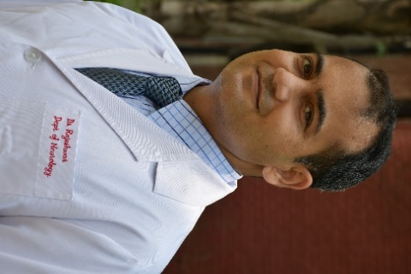
Dr Rajeshwar MBBS, MD (Medicine), DM (Neurology)
Member of AAN, IAN, WSO, ESO
Associate Professor
Department of Neurology
Christian Medical College & Hospital, Ludhiana India

Dr. Rajeshwar born in 1982, is working at Faculty position (Associate Professor) in the Department of Neurology, Christian Medical College & Hospital, Ludhiana, Punjab, India.
Training: He graduated in Medicine at the Christian Medical College & Hospital, Ludhiana. He did his master’s degree in Internal Medicine in 2010 and DM Neurology in 2018 at Christian Medical College & Hospital, Ludhiana. He is working as neurologist with special interest in Stroke Medicine and Neuro-intervention.
Research areas: He has special interest in Research related to Acute Ischemic stroke, Intracerebral Haemorrhage and Neuro-Intervention.
Ongoing Projects: 1) He is Principal Investigator in National Stroke Registry Project under ICMR-NCDIR. He is Co-PI in 2) (ENRICH-AF- EdoxabaN foR IntraCranial Hemorrhage survivors with Atrial Fibrillation), 3) Sentinel Surveillance for Adverse Events of Special Interest (AESI) following COVID-19 vaccination in India, 4) INTRINSIC TRIAL, 5) REOPEN
Completed Projects: Co-PI - 1) SPRINT INDIA: structured semi-interactive stroke prevention package in India 2) RESURRECT TRIAL: REmote ISchaemic conditioning and Fentanyl as an adjUnct to TaRgeted tempeRature Management in Hypoxic ischaEmic Brain Injury post Cardiac ArresT (RESURRECT) Study: HIBI Initiative.
Award: 1st Prize at the Chrismed Annual Research and Education Symposium (CARES) 2018, CMC & H, Ludhiana, Indian Academy of Neurology (IAN) Travel Fellowship Grant 2018, and Award of Honour, Department of Health & Family Welfare, Punjab, Mega Medical Checkup Camp, MANSA Nov 2012.
Professional: He is member of Indian Academy of Neurology (IAN), American Academy of Neurology (AAN), European Stroke Organisation (ESO), and World Stroke Organization (WSO). He had done oral presentation of his DM thesis at ESOC 2018.
Publications: He has published Five articles in National and One in International Journal with Three abstracts of original research presented in international conferences and published in international journals.
In Private: He is happily married for 12 years with his wife Vandana and father of two daughters. He enjoys travel, modern art, sports-Badminton, watching movies and Indian music.
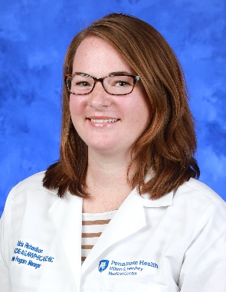
Alicia Richardson, MSN, RN, ACCNS-AG, ANVP, ASC
Program Manager, Penn State Hershey Comprehensive Stroke Center
Stroke Program Clinical Nurse Specialist
Instructor, Department of Neurosurgery

Alicia Richardson, is the Stroke Program Manager for a Comprehensive Stroke Program in Central Pennsylvania, United States of America. Alicia is currently President-Elect for the Association of Neurovascular Clinicians (ANVC).
Training: Alicia obtained her Bachelor’s of Science in Nursing from Plattsburgh State University in 2008 and her Master’s degree as a Clinical Nurse Specialist from St. John Fisher College in 2012. In 2018, Alicia completed a Post-Graduate Vascular Neurology Advanced Neurovascular Practice Fellowship program (NETSMART-AP). She has 13 years of neuroscience nursing experience and is board certified as an Acute-Care Clinical Nurse Specialist-in Adult/Gerontology (ACCNS-AG), Advanced Neurovascular Practitioner (ANVP) and Advanced Stroke Coordinator (ASC).
Research areas: She has research in the hyperacute phases of stroke care and in with the Stroke Coordinator role. She has worked with two community grants for pre-hospital stroke care and community stroke education. Alicia has participated in PROSPER, MARISS, OPTIMIST, and ZODIAC.
Awards: Alicia has received numerous awards throughout her career, in 2009 she was awarded a Medical Surgical Nursing Excellence in Precepting award, 2 years later a Medical Surgical Clinical Excellence Award, and the Denise Hartung Clinical Excellence Award. In 2013, she was awarded an Outstanding Clinical Nurse Specialist award, and in 2017 and 2018 awarded the NETSMART-AP Clinical Excellence Award and the Advanced Practice Clinician of the Year award. In 2020, she was awarded the NETSMART AP Star award for her work as program chair of the Advanced Stroke Coordinator Curricula.
Professional: Currently Alicia is the President Elect for the Association of Neurovascular Clinicians, and has been a Director at Large since 2018. She was program chair for the inaugural Association of Neurovascular Clinicians Annual Conference. Alicia has held numerous leadership positions regionally and nationally. She has been on several planning committees with SVIN and MT2020, along with regional planning committees. She has also been a board member of her hospital’s Advanced Practice Council and currently is a Professional Advancement Review Committee member.
Publications: Alicia has publications in the pre-hospital setting of COVID-19, Large Vessel Occlusion tools, and nursing ratios for mobility of stroke patients to name a few. Alicia is passionate about hyperacute stroke care and improving the timeliness to treatment.
In Private: Alicia is married to her high school sweetheart, and together they have 3 children—boy and girl twins age 10 and a daughter age 7. She also has two pitbull mix rescue puppies that are part of the family. She enjoys traveling, art, coffee, great food, and reading a good book.

Faddi G. Saleh Velez, MD
Assistant Professor, Department of Neurology
Member, Section of Stroke and Inpatient Neurology
The University of Oklahoma Health Sciences Center
Oklahoma City, OK
USA

Dr. Faddi G. Saleh Velez, is currently an assistant professor of Neurology and member of the Section of Stroke and Inpatient Neurology at The University of Oklahoma Health Sciences Center in The United States of America.
Training: He graduated in Medicine at the Medical School of the “Colegio Mayor de Nuestra Senora del Rosario/Del Rosario University” in Colombia. He completed a 2.5-years Post-Doctoral research fellowship in Neuromodulation at the Spaulding Neuromodulation Center from Harvard Medical School. He trained in Neurology at the University of Chicago and completed a fellowship training in Vascular Neurology at the University of Miami/Jackson Health System in June 2022. He is board certified in Neurology.
Research Areas: Dr. Saleh Velez has led multiple research studies evaluating the effects of different non-invasive brain stimulation techniques such as Transcranial Direct Current Stimulation and Transcranial Magnetic Stimulation for motor recovery, autonomic dysfunction, and other post stroke symptoms as well as in different neuropsychiatric disorders such as neuropathic pain, spinal cord injury and traumatic brain injury. He has led several quality improvement projects in stroke care, through the creation and validation of screening tools to determine missed diagnostic opportunities in stroke in the emergency department as well as rapid identification of inpatient strokes in order to improve stroke metrics. Furthermore, his research focuses on assessing neuroimaging characteristics as well as pathophysiologic mechanisms that can affect stroke etiology, leading to developing patient-driven individualized therapeutic approaches in neurovascular disorders for acute, subacute and chronic phases post stroke. Additionally, he has interest in uncommon etiologies of stroke, including genetic disorders and cerebrovascular complications in patients with mechanical circulatory assist devices.
Awards: Dr. Saleh Velez has been recognized in the past among one of 4 ESO young research investigators awards from the European Stroke organization conference in Milan, Italy in 2019. Additionally, he was awarded with the research of the year award at the Arnason’s symposium in 2019 as well as selected the recipient of the resident researcher of the year from the University of Chicago Neurology department in 2021. Moreover, he received the Futures in Neurological Research (FiNR) award from the American Academy of Neurology in 2021 as well as a travel grant from young investigators from LINNC in 2021. He was also part ofthe team that received the Neurocritical care society 2021 best mentorship project award.
Professional: He is a member of the American Academy of neurology, the American Heart Association, The society for Neuroscience as well as the World Stroke Organization. He is currently the treasurer for the Society of Neuroscience Oklahoma Chapter and a board member. Moreover, he is a senior blog ambassador for stroke journal from the American Heart association since 2021.
Publications: Dr. Saleh Velez, has published more than 25 articles and over 30 abstracts. Some of his publications include the demonstration of the effects of SSRIs combined with transcranial magnetic stimulation to enhance motor recovery post stroke. He has presented his research findings at national and international conferences and has over 200 citations from his work (google scholar citations). He is member of the editorial review board of Brain Imaging and Stimulation from Frontiers in Human Neuroscience Journal since 2020.
Personal: He is happily married with his wife Camila B. Pinto, a successful neuroscience PhD with whom he usually shares many of his research projects and collaborations. He recently became a father approximately 7 months ago, which he considers the most rewarding and most important of his achievements. He loves traveling and enjoys playing and watching almost any sport.

Tamer Mahmoud Roushdy –
Associate Professor of Neurology at faculty of Medicine - Ain Shams University – Cairo – Egypt.
I am a PhD. MD holder in Neurology.
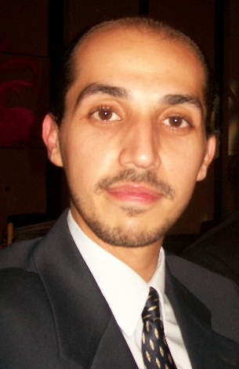

I graduated from school of medicine in 2006 and since then I have joined Neurology department and promoted within the department from resident to Assistant Lecturer in 2010 then to Lecturer in 2015 and then to Associate Professor in 2021.
My PhD was discussing the role of transcranial magnetic stimulation in post stroke aphasia. And since 2015, my scientific research is focusing on stroke and vascular neurology. I have 32 publications on Scopus since 2017 “Scopus Author identifier 57199153699”.
I have participated with my colleagues in achieving LGA accreditation for the stroke units of Ain Shams University hospital and Ain Shams University specialized hospital.

I was responsible for the training of residents to apply NIHSS for stroke cases in ER and was on call with them in decision regarding thrombolysis administration since its endorsement by ministry of health after a campaign that was led by Ain Shams Neurology department and I’m glad that my work was one of the factors that persuaded the ministry of health to endorse such treatment after a study that was published in international journal of stroke under the title “Egyptian experience in increasing utilization of reperfusion therapies in acute ischemic stroke”.
I led a study assessing stroke service availability in Africa that was recently published in international journal of stroke.

With my colleagues and despite the effect of Covid-19 pandemic yet we have learned much in dealing with stroke and Covid and we have published more than 7 publications in this special field including modified pathway for acute stroke management to achieve protection for doctors who are providing stroke services and avoiding any delay for patients in receiving their thrombolysis/thrombectomy therapies.
Together with colleagues in the initiative of treat and teach we provide virtual training program to Somalia through Telemedicine and Telestroke. Along the past few years, I have supervised the Ain Shams University RESQ and SITS sites and I am the local coordinator for the EGASU SITS site.
On regular basis with the support of the Angels initiative I have trained different members of stroke units in Egypt and elsewhere like Jordan on applying for WSO - RESQ awards through zoom sessions. Since January 2021, I am the manager of the stroke center at Ain shams university specialized hospital.

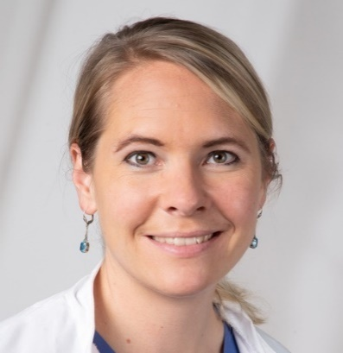

Christine Tunkl

Christine graduated in Medicine at the University of Heidelberg in 2016. After her MD she has been working in the Department of Neurology, University Hospital of Heidelberg, where she focused her clinical and research work on vascular neurology and critical care. She has spent several years on the stroke unit, neuro-intensive care unit and emergency department and provided telestroke services within the regional “FAST” network.

Christine’s early research activities addressed social determinants of health and she wrote her doctoral thesis about “Disparities in health and access to health care among asylum seekers in Germany”. Through exchanges with participants from different countries at the European Stroke Organization Summer School in Helsinki, Christine became aware about the inequities in access to stroke care. Knowing that nowadays we already have the technologies, the knowledge and skills in stroke care – she realized that it’s about making all this accessible to more patients.

In 2020, Christine established a cooperation between the University of Heidelberg and the Nepal Stroke Association. With the guidance from Professor Werner Hacke and the Angels‘ Initiative this quickly turned into a successful nationwide project (nepalstrokeproject.org), supported by the Deutsche Gesellschaft für Internationale Zusammenarbeit (GIZ) and financed by the German Federal Ministry of Economic Cooperation and Development (BMZ) and the Else Kröner-Fresenius foundation (EKFS). The project aims to improve quality of stroke care by establishing stroke-ready hospitals in all provinces of Nepal, to implement quality monitoring, to raise public awareness on stroke – and last but not least: To provide evidence-based solutions for implementation of stroke care in the resource-limited health care systems.
The project is still ongoing, and the first results are in process of publication and are presented on the World Stroke Congress 2022.

Christine’s further postdoctoral research activities addressed the role of gut microbioma in ischemic stroke and the prediction of outcome in small-vessel disease. Apart from the clinical and scientific work, Christine enjoys her regular teaching activities at the Medical Faculty of the University of Heidelberg as much as in Nepal. And of course, there’s always a life outside the hospital, and Christine enjoys learning new languages (Nepali at the moment, which is too difficult to be enjoyable though) and recently discovered her passion for Yoga.

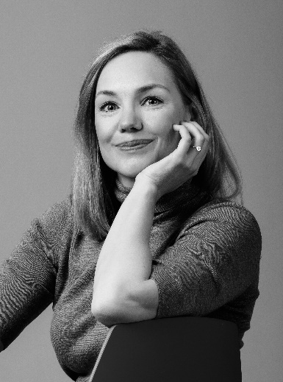

Teresa Ullberg
Senior consultant and associate professor of neurology

I grew up in northern Sweden but chose to study medicine at the University of Copenhagen in Denmark. In medical school I had the opportunity to work in a neurology department. Instantly fascinated by stroke medicine I decided to become a neurologist. Later, in tandem with my neurology residency, I completed my PhD thesis “Perspectives on post-stroke care and outcomes” in 2016. Since 2017 I have worked as a neurologist, with a particular interest in vascular neurology. I am sub-specialized in interventional neurology and currently hold a position as a senior consultant vascular neurologist at Skåne University Hospital. I teach neurology to medical students, and frequently give lectures on stroke in Sweden and internationally.

I am an associate professor of neurology at Lund University. Recently I became head of the Stroke, Policy and Quality-Register Research Group, taking over from my mentor Professor Bo Norrving who has successfully led the group for many years. Together we supervise several PhD students on clinical stroke research projects, including management of patients with severe intracerebral hemorrhage, anticoagulant-related intracerebral hemorrhage, and automated evaluation of volume and other metrics of intracerebral hemorrhage. Other projects relate to Swedish register data on endovascular therapy. A study on climate effects on stroke is in the advanced planning stage.

My experience working with stroke policy questions locally and on a national level in Sweden sparked my passionate interest in global stroke issues. I look forward to increasing my knowledge about global aspects of stroke, improving my skills in stroke advocacy and policy making, and learning more about the strategic goals set by the World Stroke Organisation and how to achieve them in different parts of the world. Global aspects of life after stroke, and the perspectives of patients and their families or caregivers, are issues that deeply engage me and I am eager to learn more about them.

When not working, I enjoy reading, hiking in the mountains or forests, and spending time with family and friends.

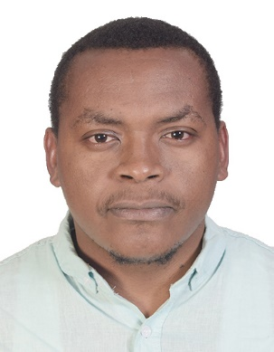

Peter Waweru MBChB, MSc.
Neurosurgery Registrar
Department of Neurosurgery
Kenyatta University Teaching, Referral and Research Hospital, Nairobi

Peter Waweru, born in 1988, is the chief resident in the department of Neurosurgery, Kenyatta University Teaching, Referral and Research Hospital, Nairobi and will graduate in two (2) months having been in neurosurgical fellowship training from 2017.
Training: He graduated in Medicine at Moi University, School of Medicine in Eldoret, Kenya and is also a holder of a Master´s degree in Stroke Medicine from Danube University, Krems, Austria. He is also in neuro-interventional training with the European Society of Minimally Invasive Neurological Therapy (ESMINT); and is expected to graduate with the European Diploma in Neurointervention (EDNI) in September 2023.
Research areas: Dr. Waweru is passionate about hemorrhagic stroke research. His current study on hemorrhagic stroke patterns and outcomes in Nairobi, Kenya. Previous projects include outcomes of patients after subarachnoid hemorrhage (SAH) in Kenya. Additionally, he is focused on developing sustainable stroke care systems in Sub-Saharan Africa, and has been involved in recent projects mapping stroke services in Kenya and in sub-Saharan Africa.
Professional: He is a member of the World Stroke Organization (WSO), European Stroke Organization (ESO), African Stroke Organization (ASO), and the European Society of Minimally Invasive Neurological Therapy (ESMINT).

Publications: His publications cover diverse areas of stroke medicine including the global impact of the COVID-19 pandemic on stroke volumes and cerebrovascular events; availability of stroke services in Africa; and stroke care in Kenya. He has also published on functional outcomes after SAH in Kenya.

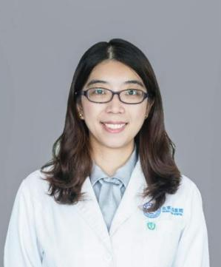
Yunyun Xiong, M.D.,Ph.D., is a chief physician and associate professor, deputy head of Division of Vascular Neurology, Department of Neurology, Beijing Tiantan Hospital.

She received her M.D.from Fudan University in 2006, and was trained as a fellow in Huashan Hospital affiliated to Fudan University in Shanghai in 2008. Then she received her Ph.D. degree from the Chinese University of Hong Kong in 2011, and subsequent Postdoctoral fellowship in 2012. She was trained as a research fellow on acute reperfusion therapy and artificial intelligence in BIDMC, Harvard Medical School from 05/2018 to 08/2019.
Her research focuses on reperfusion therapy and artificial intelligence in acute ischemic stroke. She has published 84 peer-reviewed SCI papers, with featured articles published on Circulation research, Stroke, JNNP etc, and received 3 NSFC grants in China. She is the co-PI for the first retrospective multicenter thrombectomy registry in China (The endovascular treatment for acute anterior circulation ischemic stroke registry [ACTUAL]), and was responsible for the study design of Endovascular treatment versus standard medical treatment for vertebrobasilar artery occlusion (BEST) trial and the ongoing Tenecteplase Reperfusion therapy in Acute ischaemic Cerebrovascular Events Ⅲ (TRACE Ⅲ, NCT05141305).
She has broad stroke networks in China, with close collaborations with more than 100 comprehensive stroke centers that are capable for thrombolysis and endovascular treatment. Besides, she is very active with international collaborations. She used to take part in the Vitamins to prevent stroke (VITATOPS) trial MRI substudy in Hong Kong, the small vessel disease epidemiology study among China, Hong Kong and Australia, and joined in the WSO BEAT program.

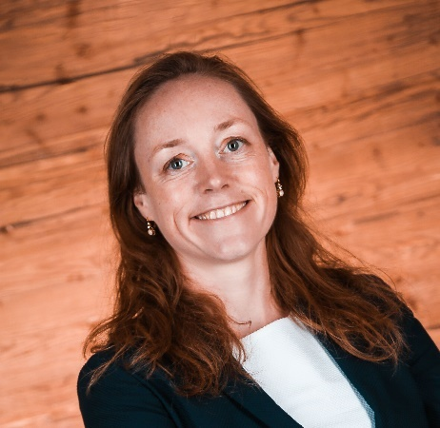

Susanna Zuurbier

Susanna Zuurbier is a Dutch Neurologist. She graduated her master's degree in medicine with honors from the University of Amsterdam. She received her Ph.D. in Cerebral Venous Thrombosis and completed her neurology training at the Amsterdam University Medical Center.
After finishing her neurology residency, she started a 1-year neurovascular fellowship at Antwerp University Hospital in Belgium. She completed the Clinical Scholars Research Training Certificate Program at Harvard Medical School. Additionally, Susanna completed the European Academy of Neurology Clinical Fellowship at the Stroke Clinic Centre for the Prevention of Stroke and Dementia at the John Radcliffe Hospital in Oxford.
She also completed a research fellowship at the University of Edinburgh, Centre for Clinical Brain Sciences, focusing on intracerebral haemorrhage under supervision of Professor Al-Shahi Salman. She was awarded a Dutch Neurovascular Science prize in 2020 for the most deserving neurovascular publication in the past two years.
Susanna Zuurbier is currently chair of the Young Stroke Professional Committee of the World Stroke Organization and a member of the European Stroke Organisation Simulation Committee.
She has authored or co-authored over 50 peer-reviewed papers and book chapters. Her primary research interests are cerebral venous thrombosis, intracerebral haemorrhage, and cerebral cavernous malformations.

